**Major Economics Department Collaborations**

Lahore School of Economics has the following ongoing exchange programs with 6 international partner universities and 1 industrial collaboration with the Lahore Chamber of Commerce and Industry Collaboration (LCCI).

**Partner Universities:**

* Undergrad Exchange Program with Macquarie University, Sydney, Australia
* Undergrad exchange program with Bahcesheir University, Istanbul, Turkey
* Undergrad Exchange Program with University of Colombo, Sri Lanka
* Undergrad Exchange Program with University of Peradeniya, Kandy, Sri Lanka
* PhD. Economics Student Exchange Program with the University of Oxford, UK
* PhD. Economics Student Exchange Program with the University of Warwick, UK

**Industrial Collaborations:**

* Lahore School of Economics and Lahore Chamber of Commerce and Industry Collaboration

**Recent News on Collaborations**

**\_\_\_\_\_\_\_\_\_\_\_\_\_\_\_\_\_\_\_\_\_\_\_\_\_\_\_\_\_\_\_\_\_\_\_\_\_\_\_\_\_\_\_\_\_\_\_\_\_\_\_\_\_\_\_\_\_\_\_\_\_\_\_\_\_\_\_\_\_\_\_\_\_\_\_\_\_\_**

**Lahore School of Economics Undergrad Students Visit Macquarie University, Australia on Study Tour in August, 2016**

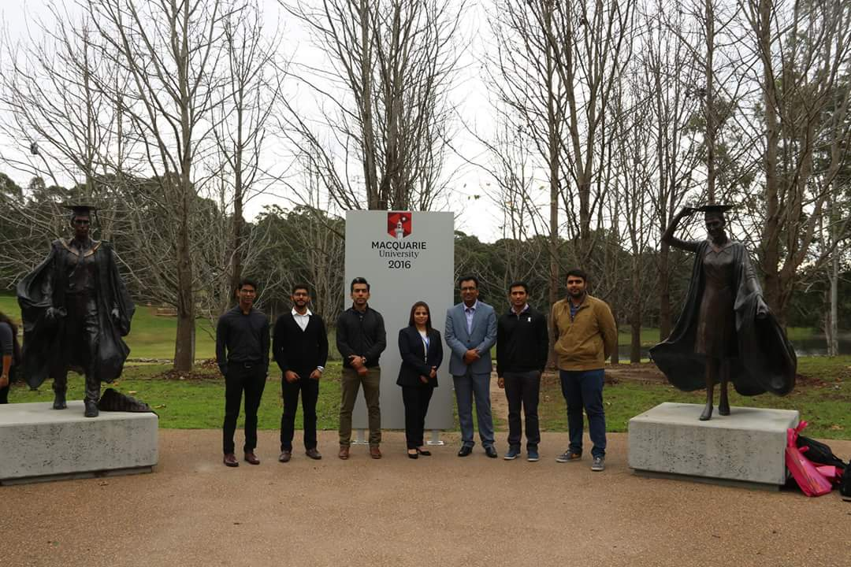

The Lahore School of Economics arranged a two week study tour for five of its students at the Macquarie University, Australia in August, 2016. These students had the opportunity to interact with their fellow students from the host university and attend special class on Social Entrepreneurship by Associate Professor, Debbie Haski. The student also went site seeing in Sydney.

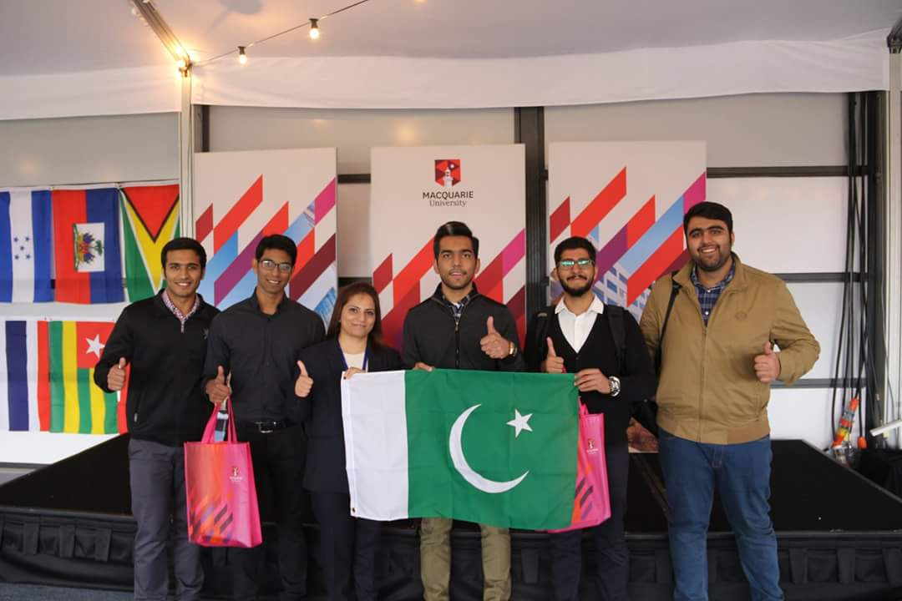

Hamza Sadiq, Abdullah Nadeem, Ameer Hamza, Qasim Naeem and Zoraiz Chaudhry are among students who visited Macquarie University, Australia. Ms. Sehrish Ehtisham, Manager, External Relations, LSE, guided them in the tour.

**LSE Students Visit University of Colombo, Sri Lanka on Study Tour in July, 2016**

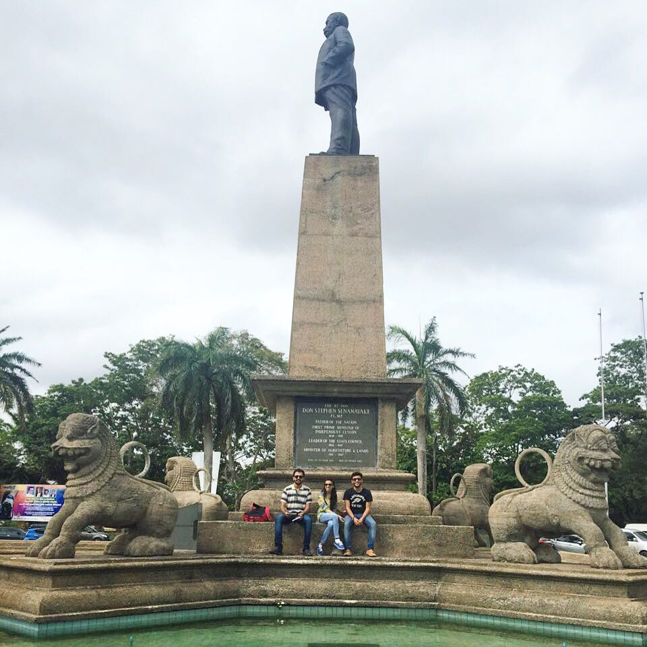

The Lahore School of Economics arranged a four week study tour for three of its undergraduate students to the University of Colombo, Sri Lanka in July, 2016. The study tour focused on subjects like economics of tourism development and research methods .The students learned how to use SPSS and its utility in data analysis for conducting research. The students also visited various places of historical, cultural and heritage importance and interacted with local people.

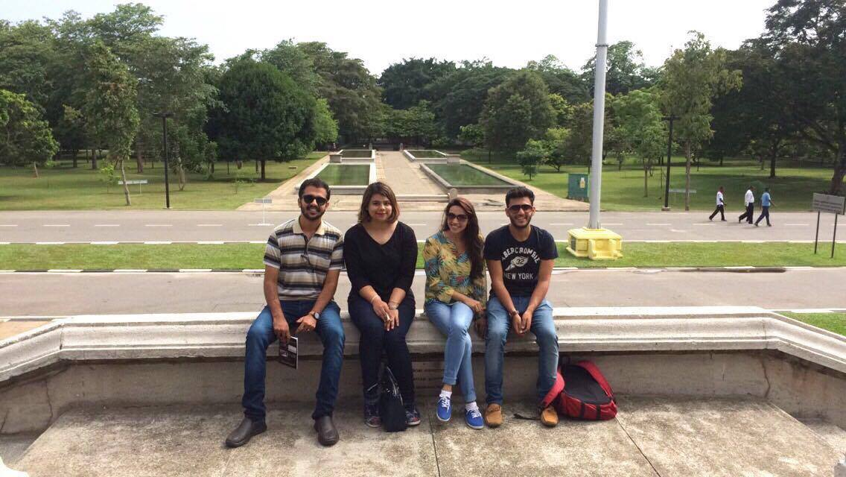

Abdullah Sajjad, Khawaja Humail Mueen Koreja and Meenal Qadir Khan are among students who participated in the study tour hosted by the University of Colombo, Sri Lanka. These students were accompanied by Ms. Ayesha Khaled, Assistant Registrar, External Relations, Lahore School of Economics.

**Warwick University, UK hosts PhD Scholars from Lahore School of Economics**

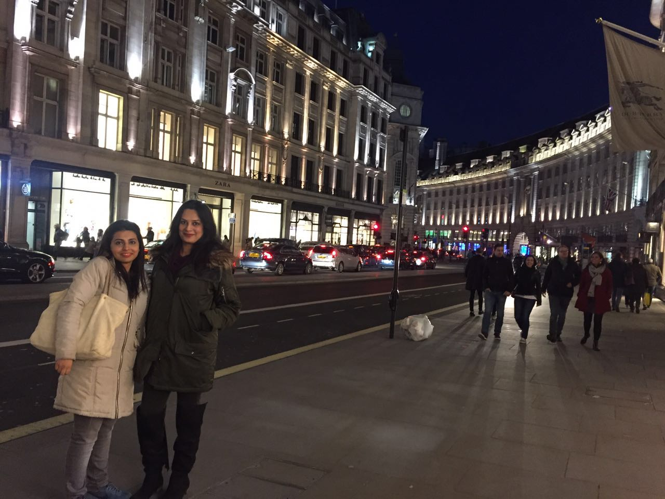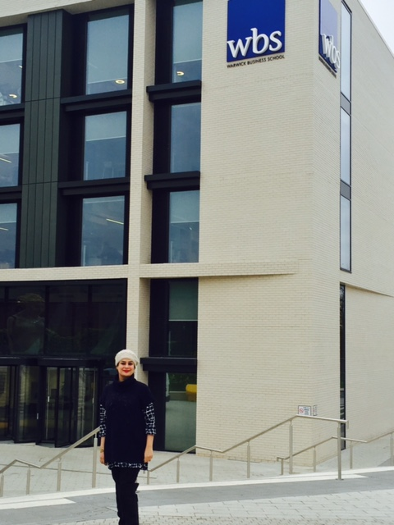

PhD. Economics students from the Lahore School of Economics went for a student exchange program to Warwick University, UK for the students’ exchange for PhD. Economics students. Ms. Nida Jamil and Ms. Rabia Arif, were the first graduate PhD. scholars from the Lahore School of Economics to visit Warwick University for a month in March, 2016. These students were guided and supervised by Professor Rocco Macchiavello and these students had the opportunity to attend the lectures of some of the top economists in the world including Christopher Woodruff. The visiting students also received necessary research guidance on their PhD proposal to further refine their research ideas and to develop their research work.

\_\_\_\_\_\_\_\_\_\_\_\_\_\_\_\_\_\_\_\_\_\_\_\_\_\_\_\_\_\_\_\_\_\_\_\_\_\_\_\_\_\_\_\_\_\_\_\_\_\_\_\_\_\_\_\_\_\_\_\_\_\_\_\_\_\_\_\_\_\_\_\_\_\_\_\_\_\_

**PhD students of LSE visit Oxford University, UK**

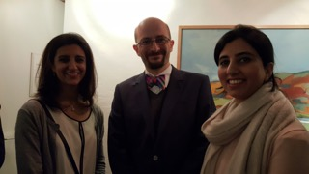

The Lahore School of Economics has an ongoing arrangement with Oxford University, UK for a graduate students’ exchange for PhD. Economics students. Two PhD. Economics students, Ms. Rabia Ikram, Assistant Professor & Research Scholar at the Lahore School of Economics and Ms. Farah Said, Assistant Professor & Research Fellow of CREB visited Oxford University, UK under this program in January, 2016. During the month's stay, the visiting scholars had interacted with a variety of researchers including Karlijn Morinsk, a post doc at Oxford, Stefano Caria (lecturer at the University of Oxford), Rocco Macchiavello (University of Warwick) and Anandi Mani (University of Warwick). They also attended graduate seminars at the University of Oxford.

\_\_\_\_\_\_\_\_\_\_\_\_\_\_\_\_\_\_\_\_\_\_\_\_\_\_\_\_\_\_\_\_\_\_\_\_\_\_\_\_\_\_\_\_\_\_\_\_\_\_\_\_\_\_\_\_\_\_\_\_\_\_\_\_\_\_\_\_\_\_\_\_\_\_\_\_\_\_

**Six Undergraduate LSE students attend a semester in Bahcesehir University, Istanbul, Turkey in 2015**

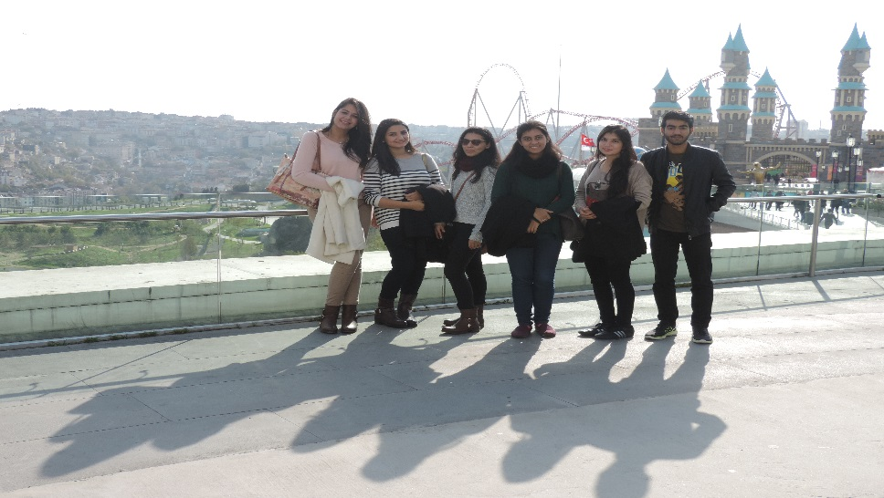

Six undergraduate students from Lahore School of Economics attended Winter Term, 2015 at Bahcesehir University, Istanbul, Turkey on full scholarship under the student Exchange Program. These students had a good experience of studying in the brother Muslim country and were deeply impressed with their culture and historical importance.

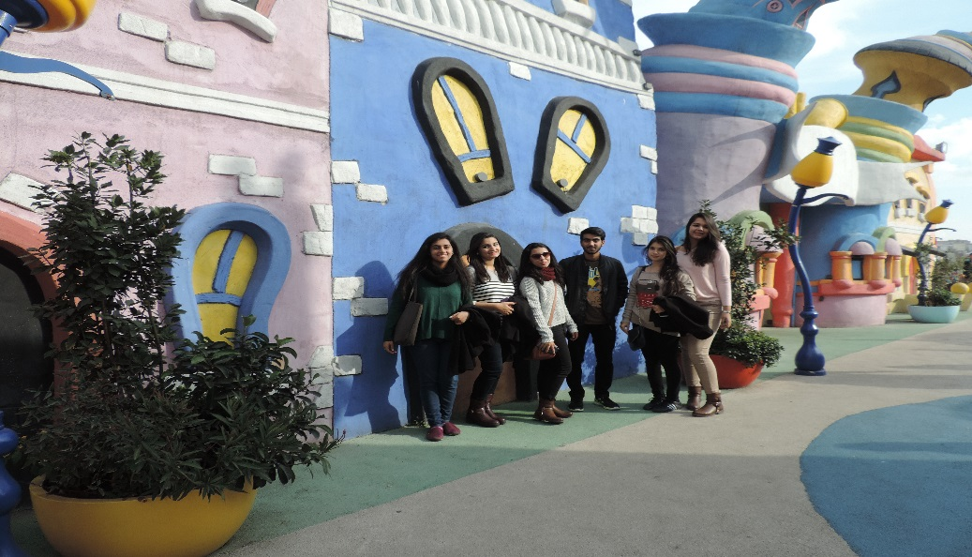

Alizeh Arif, Alizeh Khan, Arhum Mahmood, Danyal Tallat, Laiba Fatima and Wafa Shehraz are among the undergrad students who attended a semester at Bahcesehir University, Turkey.

\_\_\_\_\_\_\_\_\_\_\_\_\_\_\_\_\_\_\_\_\_\_\_\_\_\_\_\_\_\_\_\_\_\_\_\_\_\_\_\_\_\_\_\_\_\_\_\_\_\_\_\_\_\_\_\_\_\_\_\_\_\_\_\_\_\_\_\_\_\_\_\_\_\_\_\_\_

**Visiting Scholar Programme with the School of Interdisciplinary area studies at Oxford University**

In January 2015, the Lahore School of Economics launched a Visiting Scholar Program with the School of Interdisciplinary Area Studies (SIAS) at Oxford University - the Oxford-Lahore School ILM Program. The first batch of four Lahore School students from the PhD Economics program are currently registered for the Lent term and are attending lectures and seminars as well as interacting with faculty from both SIAS and the Department of Economics at Oxford to discuss their dissertation research.

**[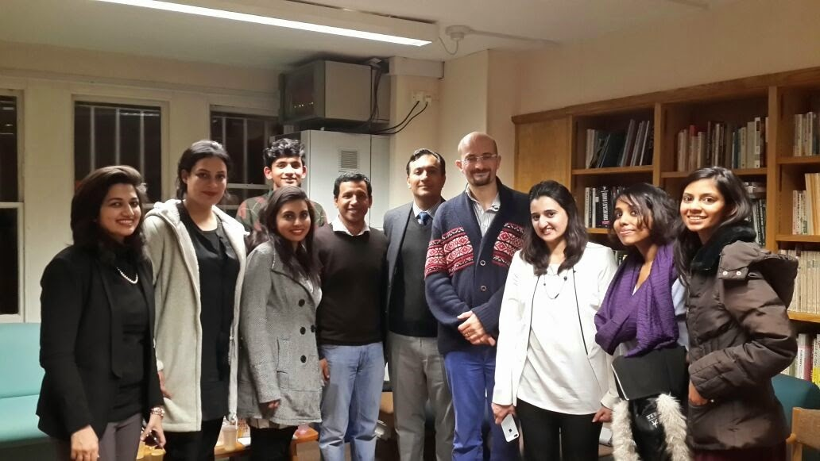](http://4.bp.blogspot.com/-avIn_zyyM6A/VM81otSacsI/AAAAAAAAMSk/1MHvSnjbx-U/s1600/Lauch+of+Oxford+Lahore+School+ILM+Program.jpg)**

The students are being hosted by [**Professor Matthew McCartney**](http://lahoreschoolofeconomics.blogspot.com/2012/05/lahore-school-eighth-annual-conference.html) (Director, South Asian Studies) at Oxford University. Professor McCartney inaugurated the ILM Program along with [**Dr. Azam Chaudhry**](http://lahoreschoolofeconomics.blogspot.com/2005/11/our-faculty-dr-azam-chaudhry.html) (Dean, Department of Economics, Lahore School of Economics) and welcomed the four scholars: Rabia Arif, Maryiam Haroon, Zunia Tirmazee and Nida Jamil. The scholars also met with **[Hermoine Lee](http://www.hermionelee.com/" \t "_blank)** (President of Wolfson College, Oxford University) to discuss areas of further collaboration between Oxford University and the Lahore School of Economics.

**[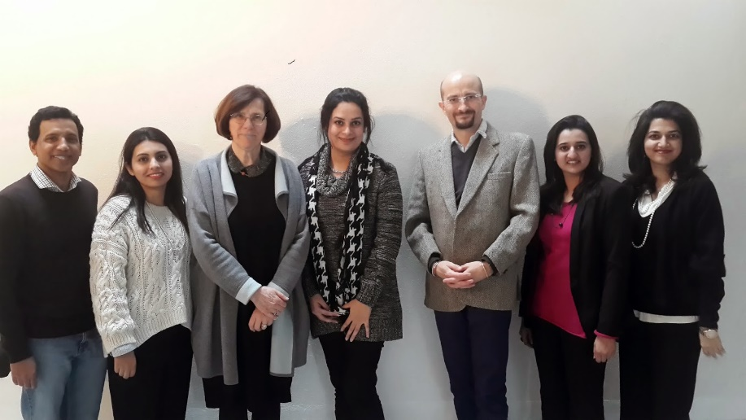](http://4.bp.blogspot.com/-zYCAHKnymHM/VM81vc1WbJI/AAAAAAAAMSs/gSfCFghtLEQ/s1600/Lauch+of+Oxford+Lahore+School+ILM+Program+2+(1).jpg)**

A reciprocal group of visiting scholars from Oxford plans to visit the Lahore School later in the spring of 2015.

\_\_\_\_\_\_\_\_\_\_\_\_\_\_\_\_\_\_\_\_\_\_\_\_\_\_\_\_\_\_\_\_\_\_\_\_\_\_\_\_\_\_\_\_\_\_\_\_\_\_\_\_\_\_\_\_\_\_\_\_\_\_\_\_\_\_\_\_\_\_\_\_\_\_\_\_\_\_

**Lahore School of Economics and Lahore Chamber of Commerce and Industry Collaboration**

Strengthening industry-academia linkage, Lahore School of Economics (Lahore School) and [**Lahore Chamber of Commerce and Industry**](http://www.lcci.com.pk/) (LCCI) inked a Memorandum of Understanding that would pave way for joint research and seminars on economic issues.

**[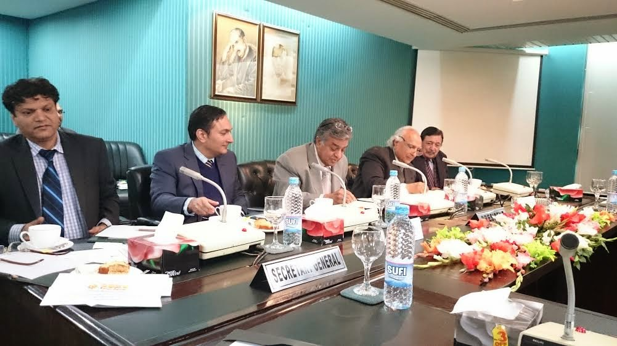](http://3.bp.blogspot.com/-vTt9ZmNz4pg/VP6H2B3_7TI/AAAAAAAAMpo/5YEKZCQp6nc/s1600/dr+shahid+amjad+chaudhry.jpg)**

The accord aims at capacity building programmes through training and empowerment by a mutual collaboration between business community and educational institutions.

LCCI and the Lahore School would collaborate for development of joint research activities and enhancement of capacity building. LCCI and Lahore School have decided to form a coordination committee.

**[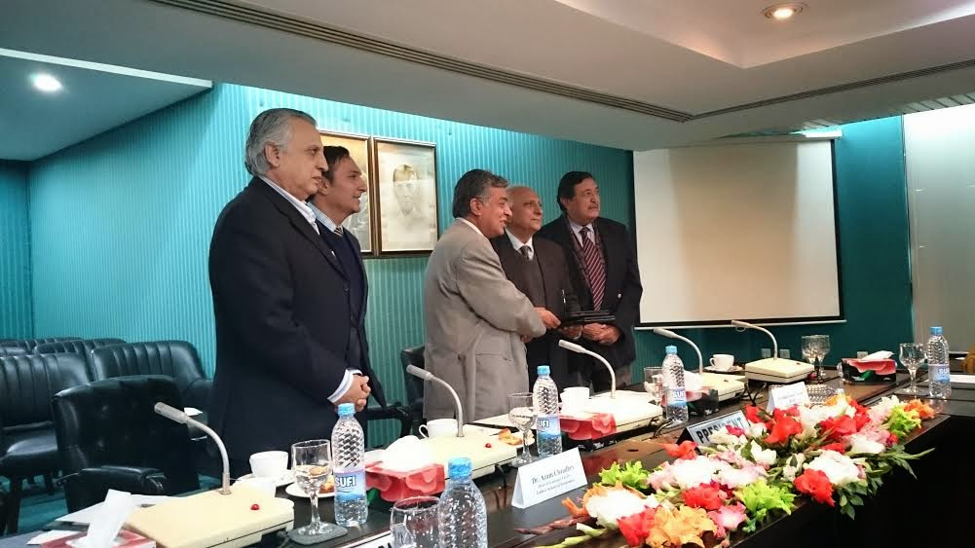](http://2.bp.blogspot.com/-ovO6RrjVbdc/VP6IB70Gj9I/AAAAAAAAMpw/c9wB6lAEWQ0/s1600/dr+azam+chaudhry.jpg)**

Both would collaborate and undertake projects to help industry compete with challenges being faced in 21st century. Both organisations would hold workshops, conferences, symposia and seminars for mutual benefits.

LCCI President Ijaz Mumtaz said accord remained a significant step in bringing institutions/academia and trade, industry together. He said the economic challenges being faced by country need tailor-made and workable solutions and this was only possible through strong academia and industry linkage. He also said there was no dearth of resources in Pakistan but it was far behind in economic race because we have failed to properly tap these resources. He also said in developed economies there was a strong linkage between the academia and industry and Pakistan today also needed to adopt that pattern to overcome its multiple issues.

Dr Shahid Amjad Chaudhry, the Rector Lahore School of Economics said that the Lahore School would provide support to Lahore Chamber on economic issues. He said the School would conduct subject-specific workshops and seminars to equip the businessmen with latest working techniques. The Lahore School would provide support to Lahore Chamber for finalisation of country’s annual budget proposals.

**\_\_\_\_\_\_\_\_\_\_\_\_\_\_\_\_\_\_\_\_\_\_\_\_\_\_\_\_\_\_\_\_\_\_\_\_\_\_\_\_\_\_\_\_\_\_\_\_\_\_\_\_\_\_\_\_\_\_\_\_\_\_\_\_\_\_\_\_\_\_\_\_\_\_\_\_\_\_**

**Lahore School of Economics and Bahcesehir University Exchange Program**

Lahore School of Economics, Lahore Pakistan and Bahcesehir University, Istanbul Turkey established long term cooperation in the areas of Faculty Exchange, Joint Research and Student Exchange.

The Lahore School has been sending students to Bahcesehir University under the Exchange Program every year since 2006.

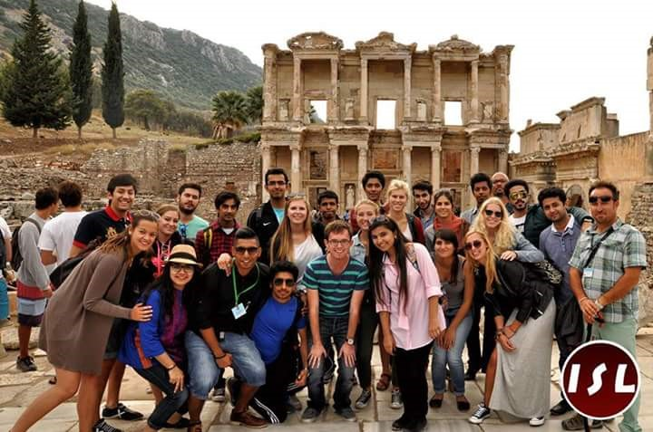

­­­­­­­­­­­­­­­­­­\_\_\_\_\_\_\_\_\_\_\_\_\_\_\_\_\_\_\_\_\_\_\_\_\_\_\_\_\_\_\_\_\_\_\_\_\_\_\_\_\_\_\_\_\_\_\_\_\_\_\_\_\_\_\_\_\_\_\_\_\_\_\_\_\_\_\_\_\_\_\_\_\_\_\_\_\_\_

**Lahore School of Economics and Macquarie University Exchange Program**

The Lahore School of Economics has recently established a long term cooperative relationship with Macquarie University, Australia.

As a result of this MOU, the Lahore School of Economics arranged a four weeks study tour to Macquarie University, Australia in the month of August.

Eight students enrolled in the third year of their bachelors program along with Ms. Ayesha Khaled (Assistant Manager External Relations) visited Macquarie University from the August 1 to August 29, 2015.

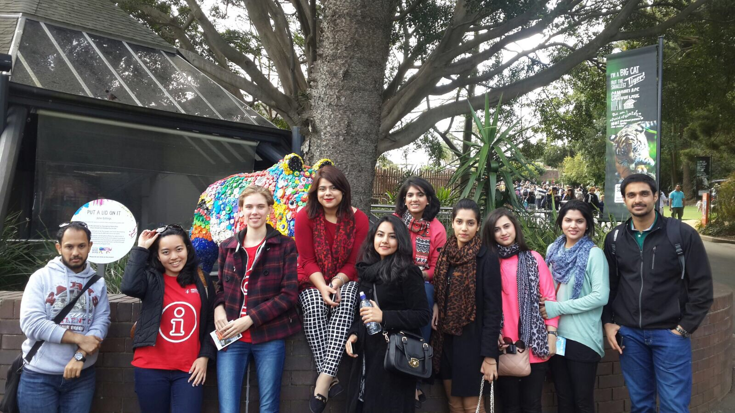

**\_\_\_\_\_\_\_\_\_\_\_\_\_\_\_\_\_\_\_\_\_\_\_\_\_\_\_\_\_\_\_\_\_\_\_\_\_\_\_\_\_\_\_\_\_\_\_\_\_\_\_\_\_\_\_\_\_\_\_\_\_\_\_\_\_\_\_\_\_\_\_\_\_\_\_\_\_\_**

**Lahore School of Economics and University of Colombo Exchange Program**

The Lahore School of Economics and University of Colombo, Srilanka have been in a cooperative academic relationship over last five years in the areas of Faculty Exchange, Research and Student Exchange.

The program has already resulted in a visit by Lahore School students to Sri Lanka with Professor Shamyla Chaudry and regular visits to Pakistan by faculty and students from the University of Colombo.

**

